Digital Lexicon
  - Dictionary
M Sairam, XII A

ACKNOWLEDGEMENT

I would like to express my special thanks of gratitude to my teacher MADHU MA’AM as well as our principal Mr. V P TONDON who gave me the golden opportunity to do this project Digital Lexicon, which also helped me in doing a lot of Research and I came to know about so many new things I am really thankful to them.
Secondly I would also like to thank my parents and friends who helped me a lot in finalizing this project within the limited time frame.

Overview
The word “Lexicon” means vocabulary of a person, language, or branch of knowledge. As a result this program was created to understand the depth of a language.
This program is an (English-English) internet dictionary application which enables a user to find meaning, antonym, and synonym and also find translation to the entered word. It also has a text to speech feature to hear a correct pronunciation for the entered word.

Modules
- PyDictionary
- Tkinter
- os
- tkMessagebox
- pyttsx3
System Requirements
Internet connection (LAN or WLAN), speakers.

Source code
#importing all the modules
from PyDictionary import PyDictionary
from Tkinter import *
import tkMessageBox
import os
import pyttsx3
#defining functions into variables
dictionary=PyDictionary()
mGui=Tk()

#considering a random variable
ment=StringVar()
# defining the geometry of the gui window
mGui.geometry('509x300+0+0')
#text for the title bar
mGui.title("Digital Lexicon")
#creating a frame for the gui interface
mFrame=Frame(mGui,width=509,height=300,relief=SUNKEN)
mFrame.pack()
#creating a label
mLabel=Label(mGui,font=("GungsuhChe",25,"bold"),text="Digital Lexicon",bd=10,anchor="w")
mLabel.place(x=130,y=0)
#functions defined for the buttons

def TextToSpeech(): #pronounces the given text in the entry box
mtext = ment.get()

engine = pyttsx3.init()
engine.say(mtext)
engine.runAndWait()

def Meaning(): #gives meaning to the provided text
mtext=ment.get()
mOutput.delete(0.0,END)
Word =(dictionary.meaning(mtext))
mOutput.insert(END,Word)

def Synonym(): #gives synonym to the provided text
mtext=ment.get()
mOutput.delete(0.0,END)
Word =(dictionary.synonym(mtext))
mOutput.insert(END,Word)

def Antonym(): #gives antonym to the provided text
mtext=ment.get()
mOutput.delete(0.0,END)
Word =(dictionary.antonym(mtext))
mOutput.insert(END,Word)

def Translate(): #translates the given text to different languages
mtext=ment.get()
Language="hi"
mOutput.delete(0.0,END)
Word =(dictionary.translate(mtext,Language))
mOutput.insert(END,Word)

def mHistory(): #displays search history
root1=Tk()
root1.title("Search History")
root1.geometry('520x200+0+0')
def exit_():
root1.destroy()
return
def clear():
os.remove(creds)
f=open(creds, 'a')
f.write(mEntry.get())
f.write('\n')
f.close()
if creds==True:
a=open(creds)
a.close()
d=open('tempfile.txt')
stri=str(d.read())

history=Text(root1,width=63,height=7,wrap=WORD,background="white")

history.delete(0.0,END)

history.place(x=5,y=10)

history.insert(END,stri)

ok=Button(root1,text="Ok",justify="center",command=exit_)
ok.place(x=400,y=140)

clear = Button(root1, text='Clear History', fg='red', command=clear)
clear.place(x=430,y=140)

Scrollbar1=Scrollbar(root1)
Scrollbar1.place(x=495,y=10)
history.configure(yscrollcommand=Scrollbar1.set)
Scrollbar1.configure(command=history.yview)
def mExit(): #exits the application
mQuit=tkMessageBox.askokcancel(title="Exit",message="Are You Sure?")
if mQuit>0:
mGui.destroy()
return

creds = 'tempfile.txt'
if creds==False:
a=open(creds,'w')
a.close()

#configures the menu bar
menubar=Menu(mGui)
#filemenu
filemenu=Menu(menubar,tearoff=0)
#configures the the exit and search history functions into the file menu
filemenu.add_command(label="Search History",command=mHistory)
filemenu.add_command(label="Exit",command=mExit)
#configures the file menu into the menu bar
menubar.add_cascade(label="File",menu=filemenu)

mGui.config(menu=menubar) #configures menu bar into the gui

#creates a entry box
mEntry=Entry(mFrame,font=("arial",20),bg="powder blue",bd=10,textvariable=ment,insertwidth=2,justify="center")
mEntry.place(x=85,y=60)
#creates a button for text to speech function
mbutton0=Button(mGui,font=("GungsuhChe",12),text="[(O)]",bd=10,justify="center",command=TextToSpeech,bg="powder blue").place(x=410,y=60)
#creates a button for meaning function
mbutton1=Button(mGui,font=("GungsuhChe",16),text="Meaning",bd=10,justify="center",command=Meaning,bg="powder blue").place(x=0,y=120)
#creates a button for synonym function
mbutton2=Button(mGui,font=("GungsuhChe",16),text="Synonym",bd=10,justify="center",command=Synonym,bg="powder blue").place(x=121,y=120)
#creates a button for antonym function
mbutton3=Button(mGui,font=("GungsuhChe",16),text="Antonym",bd=10,justify="center",command=Antonym,bg="powder blue").place(x=251,y=120)
#creates a button for translate function
mbutton4=Button(mGui,font=("GungsuhChe",16),text="Translate",bd=10,justify="center",command=Translate,bg="powder blue").place(x=378,y=120)

#creates a text box to display the output
mOutput=Text(mGui,width=63,height=7,wrap=WORD,background="white")
mOutput.place(y=180)

#scrollbar
mScrollbar=Scrollbar(mGui)
mScrollbar.place(x=491,y=180)
#configures scrollbar for the text box into the gui
mOutput.configure(yscrollcommand=mScrollbar.set)
mScrollbar.configure(command=mOutput.yview)

mGui.mainloop()

#End

Output
#Graphical User Interface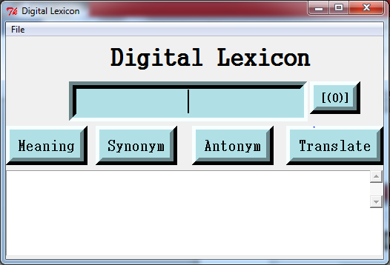#entering a word 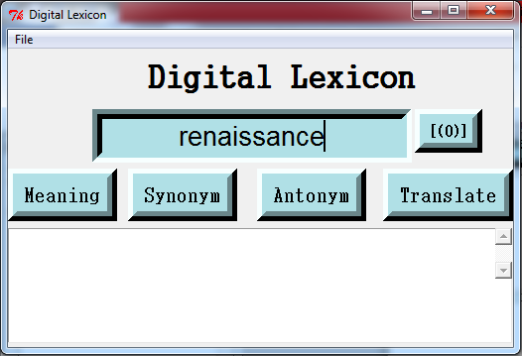
#to pronounce the word
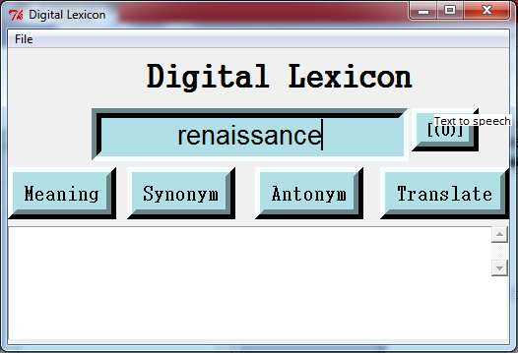
#meaning of the word
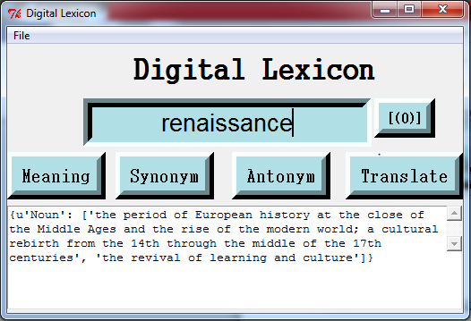
#synonym of the word
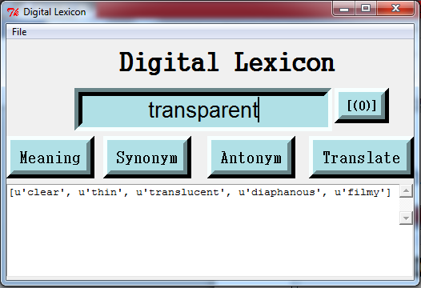
#antonym of the word
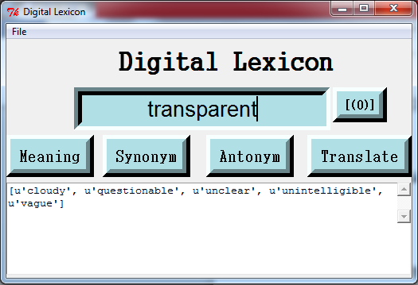
#to translate the word to Hindi
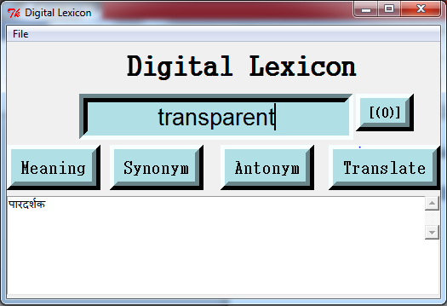
#to view the search history
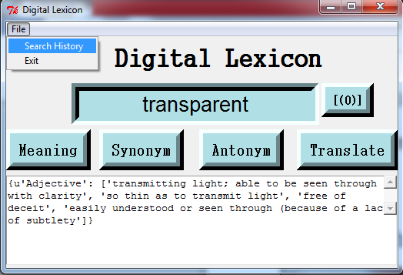
#to delete the search history
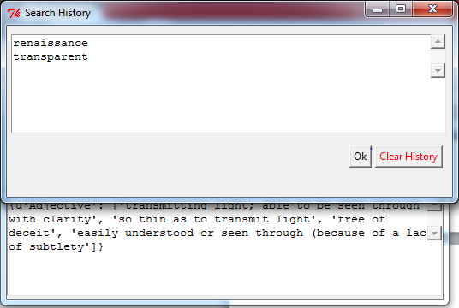
#after deletion
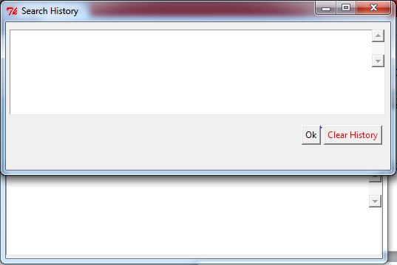
#to exit the application
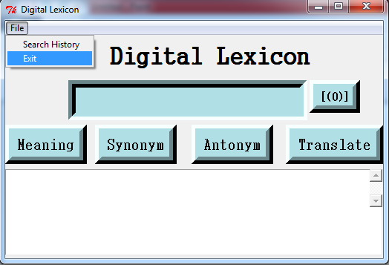
#message confirming exit
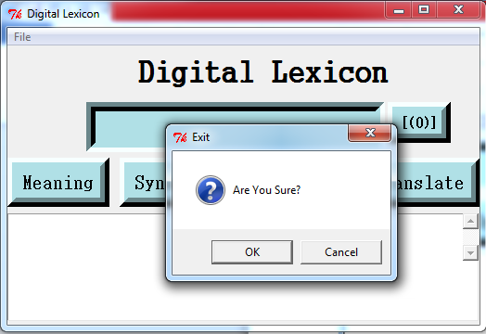

Bibliography
https://pythonspot.com/
https://www.programiz.com/python-programming/modules
https://www.google.co.in
Computer Science with Python Textbook class XII - Sumita Aurora

